

1

February2024

Category review: Chips

Retail Analytics



Classification: Confidential

# Our 17 year history assures best practice in privacy, security and the ethical use of data

We all have a responsibility to use data for good



Privacy

Security

•

•

We have built our business based on privacy by design principles for the past 17 years

Quantium has strict protocols around the receipt and storage of personal information

All information is de-identified using an irreversible tokenisation process with no ability to

re-identify individuals.

•

•

•

•

•

•

•

We are ISO27001 certified - internationally recognised for our ability to uphold best practice standards across information security

We use ‘bank grade’ security to store and process our data

Comply with 200+ security requirements from NAB, Woolworths and other data partners

All partner data is held in separate restricted environments

All access to partner data is limited to essential staff only

Security environment and processes regularly audited by our data partners.

Ethical use of data

Applies to all facets of our work, from the initiatives we take on, the information we use and how our solutions impact individuals, organisations and society.

Quantium believes in using data for progress, with great

care and responsibility. As such please respect the commercial in confidence nature

of this document.

2

Classification: Confidential

# Executive summary

Task 1: Overview of chips sales and

0

1

getting key information.

Task 2: Trial

0

2

store performance.

* Comparing chips sales overtime from 2018 to 1019.
* Impact of customer's influence and spending habits.
* Customer's life stage and influence impact on spending habits.
* Overall the trial stores outperformed the control stores in every category during this period.
* The trial stores do show a leveling out performance in the third month.
* Two out of three stores are showing higher levels in every category compared to the control stores at the end.

3

01

# Overview of Chips Sales and key information:

4



Total sales trend for past year

Sales totals for the year 2019 has decreased from 2018. Showing slight improvement in month June.

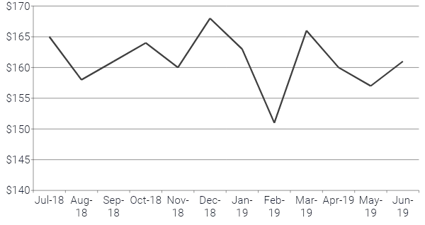

5

# Customer affluence and it’s effect on customer buying

## As we can see on the graph below mainstream customer made the made the most chips purchases with budget customers in second. It does not seem affluence has a large impact on chips sales as one would expect.

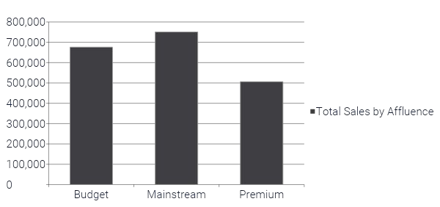

6

# Life stage with proportion of premium customer

## The data shows that older people tend to purchase more chips across all life stage demographics and affluence. With new families being the lowest.

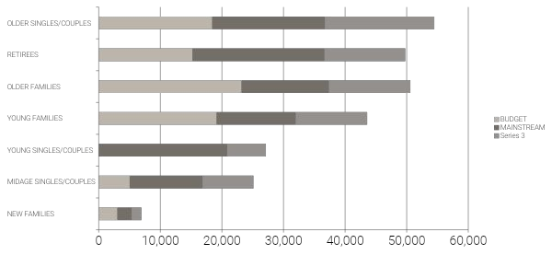

7

02

# Trial store performance

8



# Trial stores v/s Control stores

## The data shows that the trial stores have increased sales from February and ends with a slight decline in April.

* 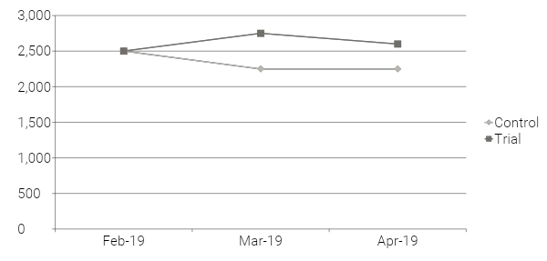The control stores declined from February and since levelled out March into April.

Total Sales during trial

9

# Trial stores v/s Control stores: Transactions

## The data shows that the trial stores have increased sales transactions from February and ends with a slight decline April.

* 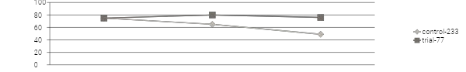Control stores declined from February, since levelled out March into April. While control store 233 continued a decline. Trail store 77 v/s Control store 233

Trail store 86 v/s Control store 155

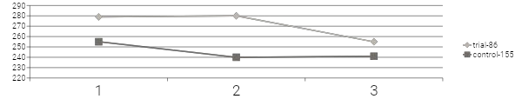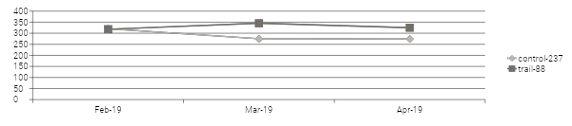

Trial store 88 v/s Control store 237

10

# Recommendations:

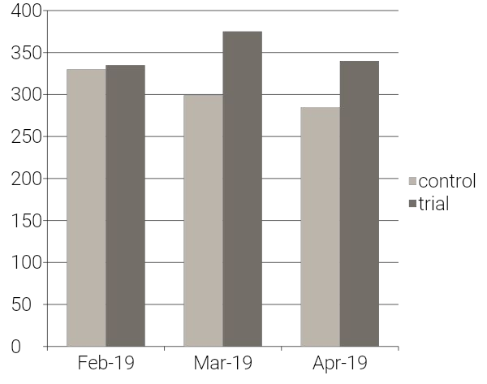Total customer chips transactions •Two of the three stores are outperforming their control stores.

* + One store continued to increase after the trial period.
  + Showing a possible change in customer purchase behaviour in store 77.
  + The other two trial stores 86 and 88 declined in sales back to it’s original sales output.
  + The data is showing some decrease in performance in the third month for the stores. A levelling out in sales is expected.

My recommendation would be to convert the stores into the new layout. After six months I would consider another study to see the impact the new layout has had across a larger sample of stores and how the sales volume is trending overtime.

11

Disclaimer: This document comprises, and is the subject of intellectual property (including copyright) and confidentiality rights of one or multiple owners, including The Quantium Group Pty Limited and its affiliates (Quantium) and where applicable, its third-party data owners (Data Providers), together (IP Owners). The information contained in this document may have been prepared using raw data owned by the Data Providers. The Data Providers have not been involved in the analysis of the raw data, the preparation of, or the information contained in the document. The IP Owners do not make any representation (express or implied), nor give any guarantee or warranty in relation to the accuracy, completeness or appropriateness of the raw data, nor the analysis contained in this document. None of the IP Owners will have any liability for any use or disclosure by the recipient of any information contained in, or derived from this document. To the maximum extent permitted by law, the IP Owners expressly disclaim, take no responsibility for and have no liability for the preparation, contents, accuracy or completeness of this document, nor the analysis on which it is based. This document is provided in confidence, may only be used for the purpose provided, and may not be copied, reproduced, distributed, disclosed or made available to a third party in any way except strictly in accordance with the applicable written terms and conditions between you and Quantium, or otherwise with Quantium’s prior written permission

12